Power Management Unit WorkBook

Created By East

Table of contents
1. Function Description 3
General Features 3
1.1 Power Management Unit 4
1.1.1 Clock Control Block 4
1.1.2 Power Manage State Machine 5
1.1.3 Reset Control Block 7
2. Register Description 8
2.1 Power Manage Control Register 8
2.2 Clock Divide Register 8
2.3 PLL Set Register 9
2.4 PLL Lock Wait Register 9

1. Function Description

General Features

The Power Management Unit has support for:
• Support Slow Mode
- Operate by External Clock
• Support CPU Idle Mode
- Disconnect Only CPU Clock
- Wake Up From Any Interrupt
• Support Power Down Mode.
- Disconnect All Clock
- Wake Up From External Interrup

Power Management Unit

Clock Control Block과 Power Manage State Machine, Reset Control Block으로 나눌 수 있다.

Clock Control Block

외부 27MHz Oscillator의 입력을 받은 MPLL에서 200MHz Clock을 만들어서 CpuClk, SysClk, PeriClk, LcdClk을 만들고, 외부 Crystal 입력을 분주하여 USB로 Clock을 건네 주는 역할을 한다.
정상 동작 모드의 예를 들면 200MHz Clock은 DDR Memory Control을 위해 사용될 뿐이고, 실제 버스나 CPU는 100MHz로 움직이고, Peri.는 50MHz로 움직인다.

* 각 Clock과 Reset을 TestMode(SCAN, BIST)에 의해서 외부 Clock이 선택 되도록 한다.
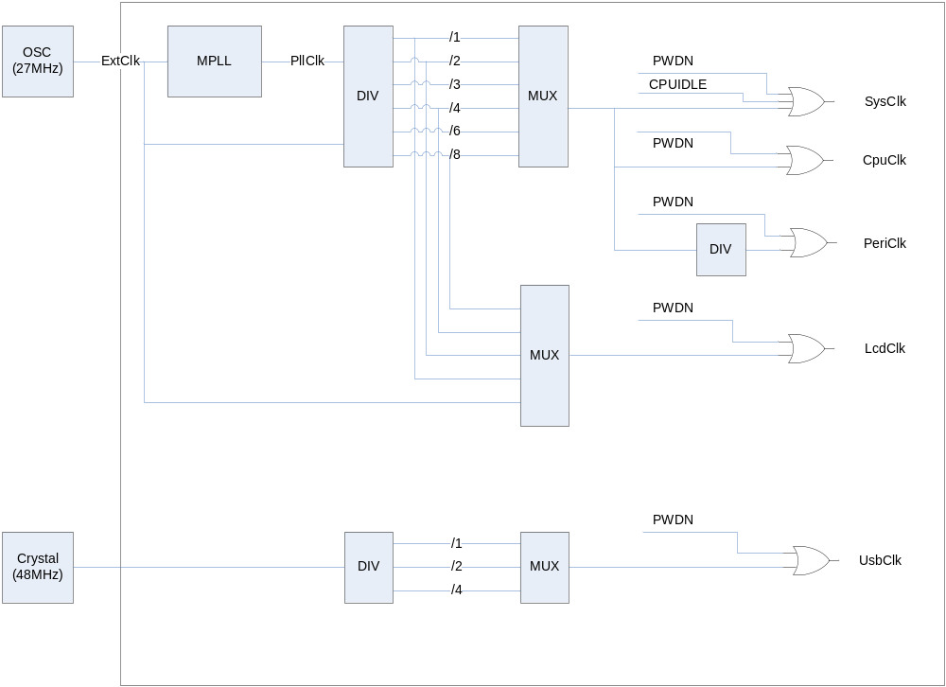
Figure1. Clock Control Block Diagram

Power Manage State Machine

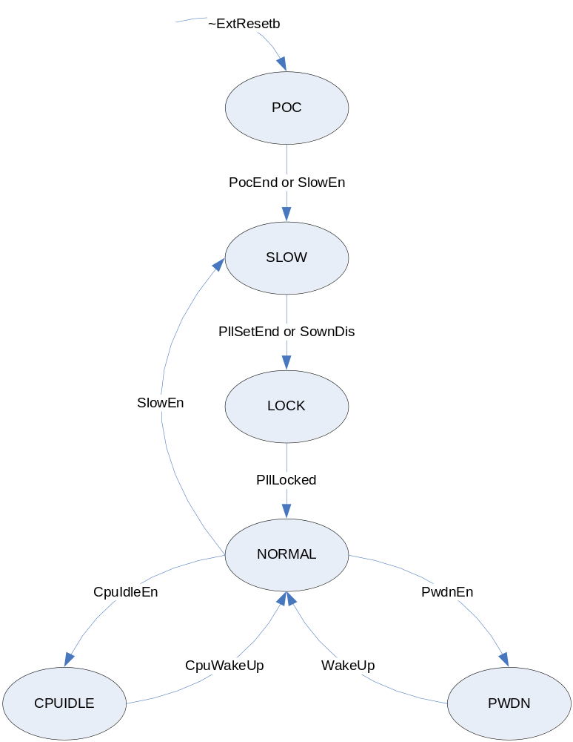

Figure2. Power Manage State Machine Block Diagram

POC State
Power On Configuration
외부 Reset(ExtResetb)이 풀리면 이 State로 들어오게 되고, 외부 입력쪽의 Pull-up이나 Pull-Down에 의해 Configuration이 가능하다.
16 Cycle 이상의 POC나 SlowEn Register가 Set 되면 SLOW State로 넘어 간다.

SLOW State
외부 Clock(ExtClk)에 의해 System이 동작 하는 상태이고, PLL이 Set 되거나(PllSetEnd) SlowEn Register가 Clear(SlowDis)되면 LOCK State로 넘어간다.

LOCK State
PLL이 Locking 될 때까지 기다리는 시간이다. 이 시간은 Register로 변경 가능하다.
PLL이 Locking 되면 NORMAL State로 넘어간다.

NORMAL State
System내의 모든 Clock이 동작하는 상태이다.

CPUIDLE State
CPU Clock이 Disable 되는 상태이다.

PWDN State
System내의 모든 Clock이 Disable 되는 상태이다.

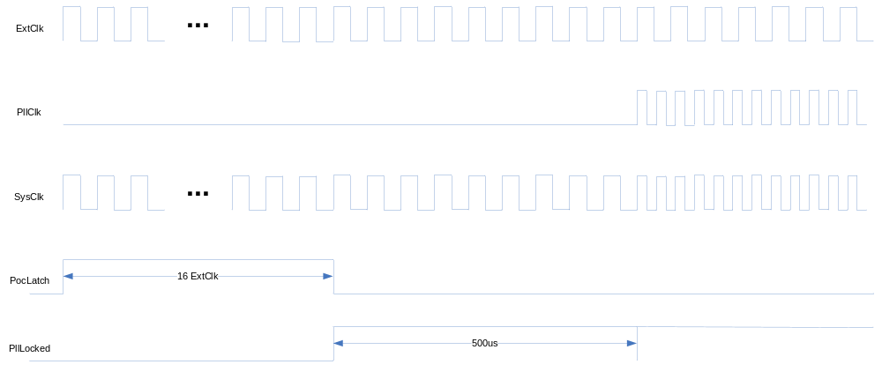
Figure3. Power On Reset & PLL Lock Time Diagram

Reset Control Block

2. Register Description

2.1 Power Manage Control Register

Register | Address | R/W | Description | Reset Value
PMCON | 0x00 | RW | Power Manage Control Register | 0
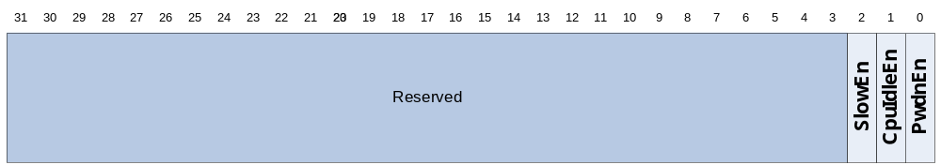
Register | Bit | Description | Reset Value
 | 31:19 | Reserved | 0
PeriClkEn | 18 | USB/SEIP를 제외한 APB Clock Enable  1 : Enable  0 : Disable | 0
SEIPClkEn | 17 | SEIP Clock Enable  1 : Enable  0 : Disable | 0
USBClkEn | 16 | USB Clock Enable  1 : Enable  0 : Disable | 0
 | 15:14 | Reserved
NANDClkEn | 13 | NAND Flash Controller Clock Enable  1 : Enable  0 : Disable | 1
DDRClkEn | 12 | DDR Memory Controller Clock Enable  1 : Enable  0 : Disable | 1
VIFClkEn | 11 | External Video Interface Module Clock Enable  1 : Enable  0 : Disable | 0
DMClkEn | 10 | Display Module Clock Enable  1 : Enable  0 : Disable | 0
DMAClkEn | 9 | DMA Module Clock Enable  1 : Enable  0 : Disable | 0
GDMAClkEn | 8 | Graphic DMA Module Clock Enable  1 : Enable  0 : Disable | 0
 | 7:3 | Reserved
SlowEn | 2 | Slow Mode Enable  1 : Enable  0 : Disable | 1
CpuIdleEn | 1 | CPU Idle Mode Enable  1 : Enable  0 : Disable | 0
PwdnEn | 0 | Power Down Enable  1 : Enable  0 : Disable | 0

2.2 Clock Divide Register

Register | Address | R/W | Description | Reset Value
CLKDIV | 0x04 | RW | Clock Divide Register | 0
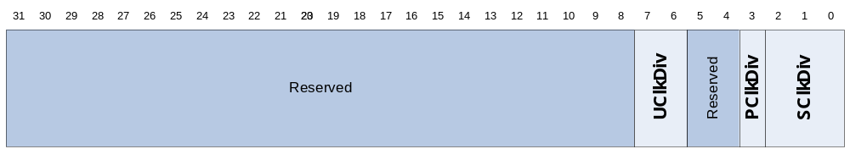
Register | Bit | Description | Reset Value
 | 31:8 | Reserved | 0
UClkDiv | 7:6 | USB Clock Divide  0 : Bypass UsbClk  1 : Divide By 2 UsbClk  2 : Divide By 4 UsbClk | 0
 | 5:4 | Reserved | 0
PClkDiv | 3 | Peri. Clock Divide  0 : Bypass SysClk  1 : Divide By 2 SysClk | 1
SClkDiv | 2:0 | System Clock Divide  0 : Bypass MPllClk  1 : Divide By 2 MPllClk  2 : Divide By 3 MPllClk  3 : Divide By 4 MPllClk  4 : Divide By 6 MPllClk  5 : Divide By 8 MPllClk | 0

2.3 PLL Set Register

Register | Address | R/W | Description | Reset Value
PLLSET | 0x08 | RW | PLL Set Register | 0
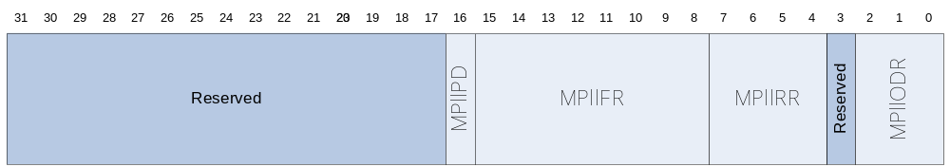
Register | Bit | Description | Reset Value
 | 31:17 | Reserved | 0
MPllPD | 16 | PLL Power Down Enable  0 : Enable  1 : Disable | 0
MPllFR | 15:8 | FeedBack Divisor
MPllRR | 7:3 | Input Divisor
 | 2 | Reserved
MPllODR | 1:0 | Output Divisor

2.4 PLL Lock Wait Register

Register | Address | R/W | Description | Reset Value
LOCWAIT | 0x0C | RW | PLL Lock Wait Register | 0
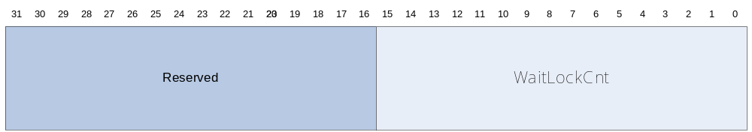
Register | Bit | Description | Reset Value
 | 30:16 | Reserved | 0
WaitLockCnt | 15:0 | PLL Lock Wait Value | 0xffff

